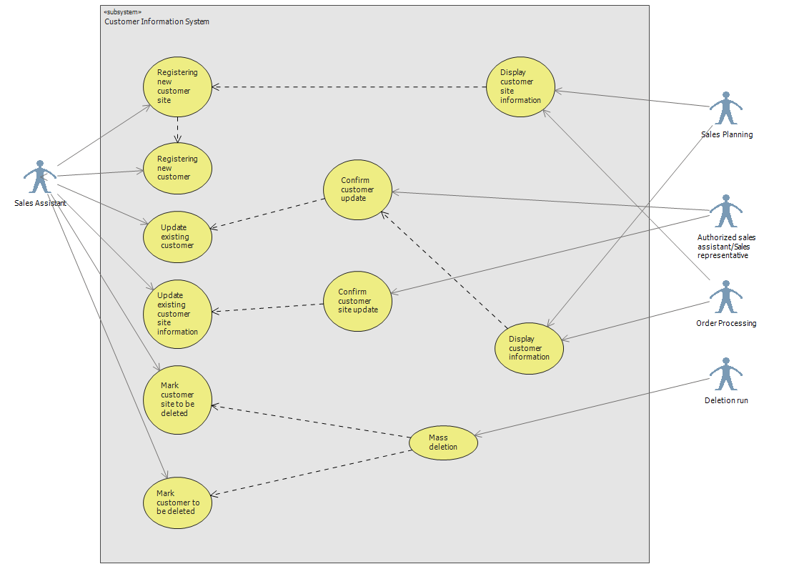

# Actors

**Sales Assistant**

Sales Assistant is a person who is responsible of managing customer and customer site information. If there are needs on managing customer’s information or customer site, creating, updating and marking for deletion. Sales person makes those necessary changes or marking for deletion, but all those changes need to be confirmed by authorized sales assistant.

**Authorized sales assistant**

All changes or deletion marks that were done by regular sales assistant need to be confirmed by authorized sales assistant.

**Sales Planning**

Sub-system; according to specific customer, sales’ planning is going to use information from customers for setting up discount rates and etc.

**Order Processing**

Sub-system which is going to use existing customers and customer sites information.

# Services

**Registering new customer/ customer site**

**Updating customer/customer site**

**Confirm customer/customer site update**

**Mark customer/customer site to be deleted**

**Display customer/ customer site information**

**Mass deletion**

# Use Cases

|  |  |  |
| --- | --- | --- |
| **Use Case** | | **Registering new customer** |
| **Actor:** | | Sales assistant |
| **Pre-condition:** | | Potential customer contacts Lahjapaja or Lahjapaja contacts potential customer. |
| **Goal:** | | Acquiring information about the customer and preparing it for the final acceptance of relationship with him. |
| 1 | Sales Assistant inserts company name, invoicing and delivery address, contact person information (name, tel. number, email, address), way of delivery, other possible info. | |

|  |  |  |
| --- | --- | --- |
| **Use Case** | | **Registering new customer site** |
| **Actor:** | | Sales assistant |
| **Pre-condition:** | | Customer site will contact LahjaPaja or Lahjapaja will contact the customer |
| **Goal:** | | Acquiring information about new customer site for the order processing purposes |
| 1 | Based on the customer ID or name the screen will show customer information/ The new customer information are being inserted into the system | |
| 2 | The customer site information is added to other customer sites/ the customer site information is inserted as the consequent process of Registering new customer use case. The Site name, addresses, contact person information, way of delivery information will be inserted. | |
| 3 | Verification of the customer site ID and stored site information | |

|  |  |  |
| --- | --- | --- |
| **Use Case** | | **Update existing customer** |
| **Actor:** | | Sales assistant |
| **Pre-condition:** | | customer or someone in house notifies of changes or errors in stored data |
| **Goal:** | | Actualization of data |
| 1 | Based on the customer ID or name the screen will show customer information. | |
| 2 | The information like customer group, name, address, contact person information, discount rate or credit limit will be marked for change and waiting to be confirmed by Authorized sales assistant. | |
| 3 | Confirmation/ Verification to the customer | |

|  |  |  |
| --- | --- | --- |
| **Use Case** | | **Update existing customer site information** |
| **Actor:** | | Sales assistant |
| **Pre-condition:** | | Customer or someone in house notifies of changes or errors in stored data |
| **Goal:** | | The existing information about customer site is updated and stored in the system |
| **1** | The actor selects the desire Customer Site by its name or ID. | |
| **2** | System deliver all information about particular customer site | |
| **3** | The actor updates fields that needed to be updated | |
| **4** | After changes were done, the actor mark it for further confirmation | |

|  |  |  |
| --- | --- | --- |
| **Use Case** | | **Mark customer site to be deleted** |
| **Actor:** | | Sales assistant |
| **Pre-condition:** | | Particular customer site is not needed in the system anymore  Lahjapaja’s decision to delete |
| **Goal:** | | The existing information about customer site is mark to be deleted from system |
| **1** | Actor selects the desire customer site by its name or ID | |
| **2** | Actor mark it for deletion | |
| **3** | Customer site will wait for mass deletion process. | |

|  |  |  |
| --- | --- | --- |
| **Use Case** | | **Mark customer to be deleted** |
| **Actor:** | | Authorized Sales assistant |
| **Pre-condition:** | | Customer is not interested anymore in business  Lahjapaja’s decision to delete |
| **Goal:** | | The existing information about customer is mark to be deleted from the sytem |
| **1** | Actor selects needed customer by its name or ID | |
| **2** | Checks if customer has any sites more | |
| **3** | Mark this customer for deletion | |
| **4** | Marked customer wait for further mass deletion process | |

|  |  |  |
| --- | --- | --- |
| **Use Case** | | **Mass deletion** |
| **Actor:** | | Deletion Run |
| **Pre-condition:** | | Certain customer or customer sites were marked for deletion by some sales assistant |
| **Goal:** | | The existing information about customer or site is deleted from the system |
| **1** | Depending on predefined date and time, actor run the mass deletion process | |

|  |  |  |
| --- | --- | --- |
| **Use Case** | | **Confirming new customer registration** |
| **Actor:** | | Authorized sales assistant, Sales representative |
| **Pre-condition:** | | Newly inserted data from the Sales Assistant |
| **Goal:** | | Final check of data and inserting another data, that Sales assistant will not have permission to insert |
| **1** | Inserts the name of the company | |
| **2** | Checks the creditability of the customer based on customer’s annual turnover and creditability information | |
| **3** | Based on the creditability information and turnover of the company, inserts discount rate %, credit limit, terms of payment, terms of delivery | |
| **4** | Defines customer group | |
| **5** | Makes contract agreement | |
| **6** | Stores customer name, invoice and delivery addresses contact person’s name, address, phone number e-mail address, contract details. | |
| **7** | Registers new customer site | |

|  |  |  |
| --- | --- | --- |
| **Use Case** | | **Display customer information** |
| **Actor:** | | Sales Planning subsystem/Order processing subsystem |
| **Pre-condition:** | | Sales Planning case: There is a need in a regular planning routine. The analysis requires displaying customer information on the screen for utilizing it for performing researches. Customers’ information is stored in the system and is available to be displayed. |
| **Goal:** | | The acquired information about a customer is utilized for sales planning analysis. |
| **1** | The actor selects a customer according to the actor’s needs. | |
| **2** | The customer information is displayed on the screen: company name, invoicing and delivery address, contact person information, way of delivery and other possible information. | |
| **3** | The actor chooses the desired information for research and processes it according to corresponding subsystem architecture and needs. | |

|  |  |  |
| --- | --- | --- |
| **Use Case** | | **Display customer site information.** |
| **Actor:** | | Sales Planning subsystem/Order processing subsystem |
| **Pre-condition:** | | Sales Planning case: There is a need in a regular planning routine. The analysis requires acquiring customer information on the screen for utilizing it for performing researches. Customer sites’ information is stored in the system and is available to be displayed. |
| **Goal:** | | The acquired information about a customer site is utilized according to particular actor’s requirements. |
| **1** | The actor selects a customer site according to corresponding subsystem architecture and the actor’s needs. | |
| **2** | The customer site information is displayed on the screen: company name, invoicing and delivery address, contact person information, way of delivery and other possible information. | |
| **3** | The actor chooses the desired information for research and processes it according to corresponding subsystem needs. | |